INSTALLING R AND RSTUDIO

R and R Studio R and R Studio are separate packages. You will need to install R first. R is the basic package we are using. R Studio is an add-on that make R easier to use for beginners. I encourage you to learn to use R, especially if you will be taking other statistics courses, where you may be expected to know how to use it. These instructions should work for Windows and MAC users for installing R and R Studio.

INSTALLING R:

* Go to http://www.r-project.org/, and in the “Getting Started” section, click on “download R.”
* Find a site of your choice. (The one at Duke university is closest to us, but it doesn’t matter.) Click to go to that site
* Click on your operating system (Windows, MAC, Linux) and follow directions.
* If Windows, click on “base” and then on Download R 3.5.2 for Windows. (Note that 3.5.2 is the current version as this is being written, but use whatever shows up as current.) You may need to save the file “R-3.5.2-win.exe,” and then click on it to execute it. When the dialog box opens, click “RUN.” A Setup Wizard should appear. Keep clicking “Next” (or change features if you understand them), until it is finished. You should now see an icon on your desktop, with a large capital “R.”

INSTALLING R STUDIO:

* Go to http://www.rstudio.com, click on “Download RStudio” and follow the directions for your operating system.

USING R AND R STUDIO

* Open R Studio by clicking on the icon in your start up menu or desktop.

INSTALLING PACKAGES IN RSTUDIO

R is an open source language, meaning that anyone can contribute to the language/ People often write useful functions for a particular analysis or format and share them with the larger R community in the form of packages. We’ll be using several packages in our analysis, but first, we need to download from the repository of R packages, or CRAN.

* The packages we’ll be using are: tidyverse, viridis, tinytex, latexpdf, data.table, growthrates, plyr

1. 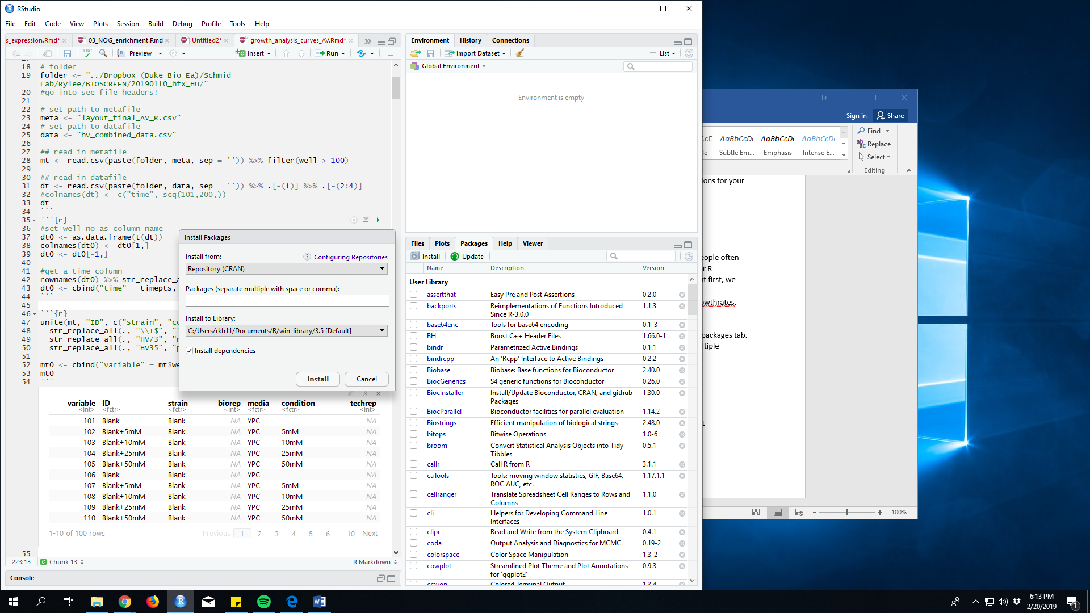Open R studio
2. In the lower right quadrant is the help manual and package manager. Click on the packages tab.
3. You can select packages using the search bar, or type them directly if installing multiple packages at once.
4. Below the tab heading there is and install icon. Click it.
5. Type each package name separated by a comma into the window. Click install.

EXITING R AND R STUDIO

* You can exit both at the same time using File→ Quit R Studio Or you can type q() at